Project Design Phase-II Technology Stack (Architecture & Stack)

Date | 18 Feb 2026
Team ID | LTVIP2026TMIDS34329
Project Name | toycraft tales: tableau's vision into toy manufacturer data
Maximum Marks | 4 Marks

Technical Architecture:
The Deliverable shall include the architectural diagram as below and the information as per the table1 & table 2
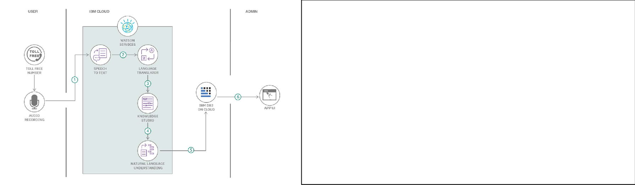
Guidelines:
Include all the processes (As an application logic / Technology Block)
Provide infrastructural demarcation (Local / Cloud) Indicate external interfaces (third party API’s etc.) Indicate Data Storage components / services Indicate interface to machine learning models (if applicable)

Table-1 : Components & Technologies:

S.No | Component | Description | Technology / Tool
1 | User Interface | Interface to view dashboard and interact with visuals | Tableau Public / Tableau Desktop
2 | Application Logic-1 | Data preprocessing and transformation | Python (Pandas), Tableau prep tools
3 | Application Logic-2 | Creating calculated fields and data filters | Tableau Calculated Fields
4 | Application Logic-3 | Visualization logic and chart rendering | Tableau Visualization Engine
5 | Database | Local storage of CSV dataset | Flat File (.CSV)
6 | Cloud Database | (Optional) Hosting dataset on cloud for Tableau Cloud usage | Google Sheets / Tableau Cloud
7 | File Storage | Where source dataset is stored before uploading to Tableau | Local Filesystem / Google Drive
8 | External API-1 | Not used (N/A for this dashboard) | N/A
9 | External API-2 | Not used | N/A
10 | Machine Learning Model | Not used in current scope | N/A
11 | Infrastructure | System used for dashboard design and publishing | Local (Windows/MacOS) / Tableau Public

Table-2: Application Characteristics:

S.No | Characteristics | Description | Technology / Tool
1 | Open-Source Frameworks | Tableau Public is free to use; Python libraries used for preprocessing | Tableau Public, Pandas
2 | Security Implementations | Local file privacy maintained; Tableau public link access can be controlled | Google Drive Permissions, Tableau's sharing controls
3 | Scalable Architecture | Tableau dashboards can be extended with additional datasets and new visuals | 3-Tier Design (Data → Logic → UI)
4 | Availability | Tableau dashboards are highly available via Tableau Public or Cloud links | Tableau Public, Google Drive
5 | Performance | Dashboards optimized by reducing unused fields, applying filters carefully, and using extracts | Tableau Extract Engine, Preprocessed CSVs

